2:00
2:05

2:30

2:55

3:00

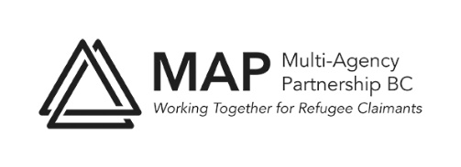
INFORMATION WORKING GROUP
Meeting Thursday March 18: 2pm on zoom
AGENDA
Welcome back! Any last minute thought about In Focus 1?
IN FOCUS #2: Efrat Arbel: Adler School of Law UBC
Canadian Refugee Law – who is it protecting? (not real title)
Jenny’s update
Discussion: responsibilities, steps and timeline for event on Thursday April 15
What is our message(s)? - for promotions, moderator
World Refugee Day (week) events:
Review of possible events to date
Area of responsibility for IWG
Discussion of ideas including writers’ workshop
Areas of interest for committee members
Next meeting date /time:
Adjourn

